Technical Report
for
RFID-BASED CHILD MONITORING SYSTEM(CMS)

Prepared by
Group Name: CS19/05
16/U/74 | 216000979 | Akol Sharon Norah
16/U/4592/EVE | 216017436 | Chekwech Emmanuel Isaiah
16/U/9075/PS | 216014557 | Nalutaayya Viola

Mentor: | Mr. Asiimwe Paddy
Course: | CSC 1304 Practical Skills Development
Date: | Monday 29th July 2019

Contents
1 Introduction 1
1.1 User Challenge 1
1.2 Project Goals 1
1.3 Functional Requirements 1
2 Project Results 2
2.1 Product Design 2
2.2 Product Functionality and Screen shots 6
2.3 Project website and repository 7
2.4 Limitatios 7
2.5 Next Steps 7
3 References 8
4 Appendix A – Project Work plan 9

List of Figures
Figure 1 : Showing Arduino Uno board 2
Figure 2 : Showing the RFID reader 3
Figure 3 : Showing the RFID tag 3
Figure 4 : Showing the alarm buzzer 4
Figure 5 : Showing the GSM module 4
Figure 6 : Showing the battery 5
Figure 7 : Showing jumper wires 5
Figure 8 : A sreenshot showing a child being detected 6
Figure 9 : A screenshot showing an SMS alert sent to the parent 7
Figure 10 : A Gantt chart showing the project work plan 10

List of Acronyms

RFID Radio-frequency Identification
CMS Child Monitoring System
GSM Global System for Mobile Communication
IDE Integrated Development Environment

Abstract

One of the most prevalent problems in homes is the infants being injured and burnt most especially in the kitchen area or losing their lives while they are outside playing while their parents are busy with work else where at home or in office. A smart child monitoring system based on Radio-frequency identification (RFID) is proposed in this paper to reduce the potential risks. The smart child monitoring system can be used in homes with integrated RFID modules and GSM modules. RFID uses electromagnetic fields to automatically identify and track tags attached to an infant. The tags contain electronically stored information. Passive tags collect energy from a near by RFID reader's interrogating radio waves.
Keywords
Micro-controller, GSM module, RFID reader, Arduino, Passive RFID tag.

Introduction
One of the biggest problems nowadays in homes is increasing rates at which infants are being injured due to accessing areas that are dangerous to them and it is high time to offer a safety support system for the infants in every home area. This paper focuses on implementing the RFID-based children Monitoring System for every child at home.

User Challenge
A parent is a caretaker of a child. Being parent means you have a responsibility of taking care of your children. However children at infant stages are there infant stages are a bit difficult to monitor for example a parent can be busy with work some where and the child crowls to a place dangerous for his or life. Such places include, kitchen area, toilets, swimming pools.
Of recent, one of Uganda’s ministers lost his twins to drowning.[1] This happened because the parent/guardian of the children were not alerted at the time the children reached the swimming pool at home which is so sad.
It is important that a system is developed to help the parents and guardians of infants at home monitor the movements of their children.An RFID- based CMS has been developed for this cause. The system will monitor a child’s movements in the home and alert the parents/guardian as soon the child reaches the vicinity of a dangerous area.

Project Goals
The main objective of the project is to develop an RFID-based Child Monitoring System that will alert the parents/guardians of children at home so as to prevent children from accessing restricted areas in home hence protecting them from injuring themselves or losing their lives.

Specific objectives

- To identify and collect the hardware components required.
- To design a system architecture.
- To implement the RFID-based CMS.
- To the test and maintain the system.

Functional Requirements
The RFID-based CMS triggers an alarm and sends an SMS message to the parent/guardian as soon as the child reaches the vicinity of the area with the RFID reader.The functionalities include;
- Identifying child with RFID tag
- RFID reader taking readings of the tag
- Triggering alarm buzzer
- Sending SMS alert to parent/guardian

Project Results

Product Design
Methodology

The main objective of the proposed system is implemented if the RFID reader is placed into the target room and RFID tag is attached to the infant. Whenever an infant moves to the target room, the tag and reader communication will occur and automatically SMS will sent to their parents and also the alerting system will activate. To avoid the infants in a home from being burnt or injured, the main objective of child monitoring system is to effectively integrate a system that could monitor infants through information technology. By using Radio Frequency Identification (RFID) technology, GSM module, and an Active RFID module embedded, a system can be generated that could ensure the complete safety of the infant.The Architecture of the RFID based child monitoring system installed in the target room of the house. It comprises of a module which senses the unique identification number (UID) from the tag attached an infant .
Hardware system
Microcontroller (Arduino Uno): This section forms the control unit of the whole project. This section basically consists of a Micro controller with its associated circuitry like Pull up resistors and so on. The Micro controller forms the heart of the project because it controls the devices being interfaced and communicates with the devices according to the program being written.
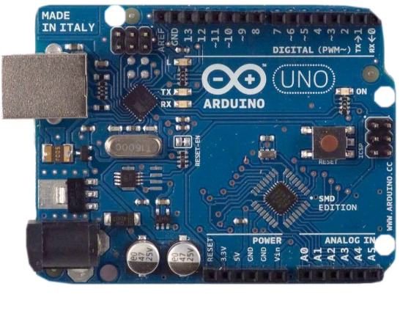
Figure 1: Showing Arduino Uno board
RFID reader: This module comprises of an Arduino microprocessor which is attached with and an RFID reader. This module takes UID from RFID reader and sends it to the Arduino Module .The reader used here is a RFID reader. RFID tags and readers have to be tuned to the same frequency in order to communicate.
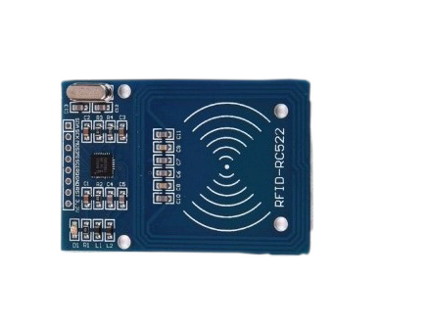
Figure 2: Showing the RFID reader
Passive RFID tag: RFID tags contain a chip which holds an electronic product code (EPC) number that points to additional data detailing the contents of the package. Readers identify the UID numbers at a distance, without involving physical contact. This the active RFID tag that will be attached to the infant such that if the infant goes to the kitchen, an alarming signal will be sent to the micro controller.
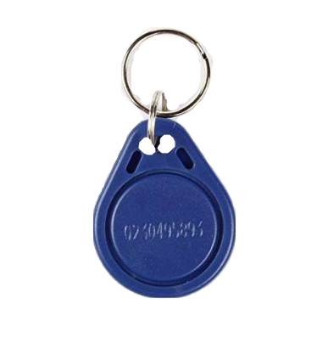
Figure 3: Showing the RFID tag

Alarm System module: This system comprises of an alarm buzzer. It will trigger the alarm if the infant appears in the target room and the RFID reader identifies the UID number.
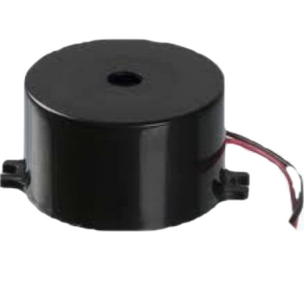
Figure 4: Showing the alarm buzzer
GSM SIM800L module
GSM SIM800L can be used to send SMS, receive SMS and make the calls. The basic GSM operations are done with the help of AT commands. The following are the AT commands used in our system:
AT: It is used to test the condition of the GSM. It responds with an OK if everything is fine or an ERROR in case of error.[2]
AT+CMGF=1: Command to set the communication to Text Mode.[2]
AT+CMGS=[Mobile Number]: Command to send SMS from the GSM Modem to particular number as mentioned in command.[2]
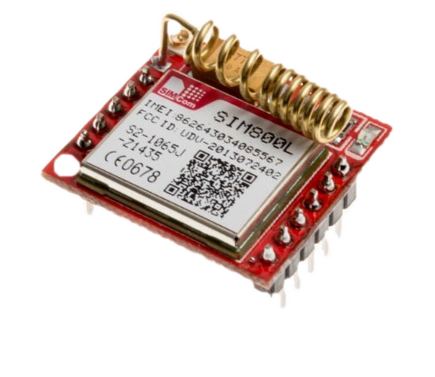
Figure 5: Showing the GSM module
Battery: The battery powers on the Arduino Uno board and the GSM module
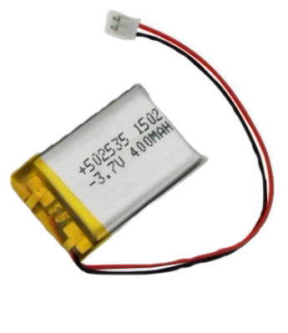
Figure 6: Showing the battery
Jumper wires: These wires are used to make connections for the system.
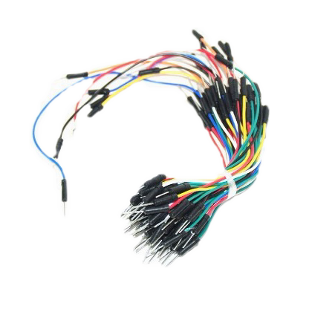
Figure 7: Showing jumper wires

Software system
We used Arduino IDE and C programming language to write the code.
We used html, CSSand javascript to do the project website

System architecture
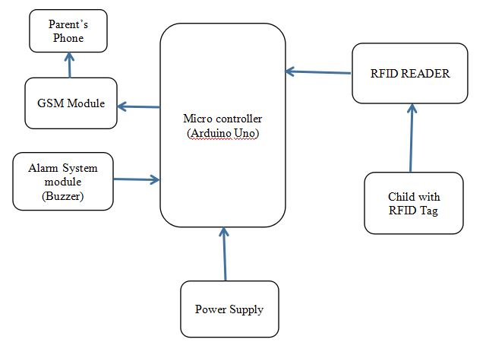

Product Functionality and Screen shots
Detecting the child with a tag
When a a child with an RFID tag comes to the vicinity ot the area with the RFID reader, the system is able to detect that child.
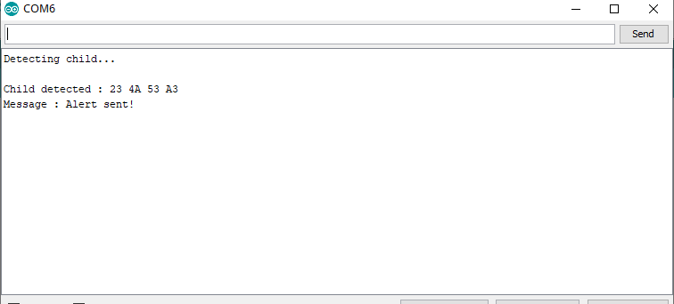
Figure 8: A sreenshot showing a child being detected

Sending an SMS message.
The system can send an SMS message alert to the parent/guadian.
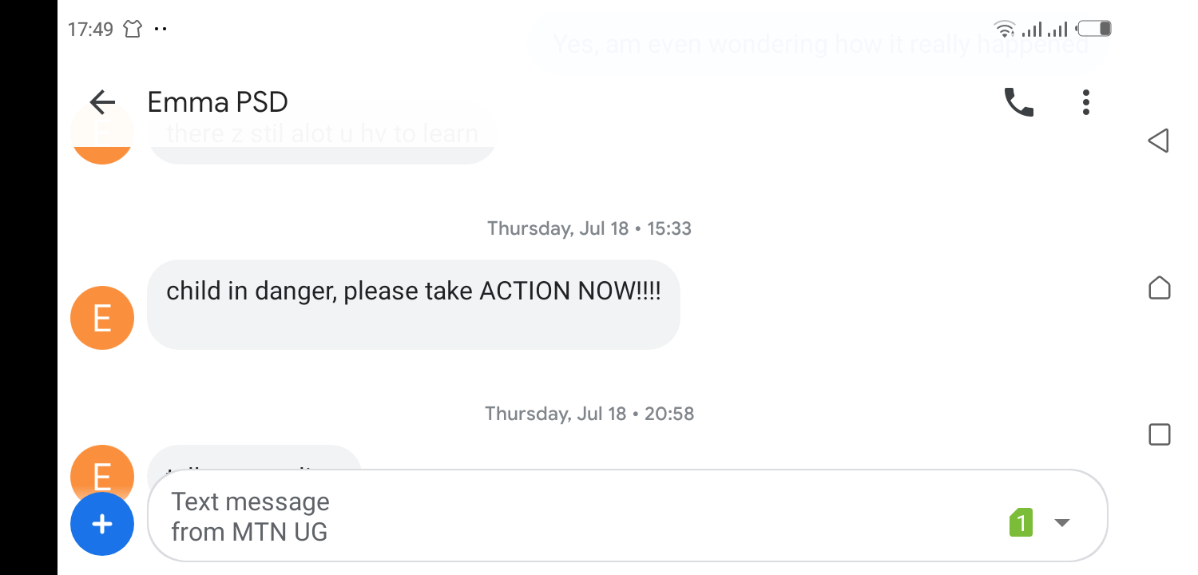
Figure 9: A screenshot showing an SMS alert sent to the parent

Triggering an alarm
The system can trigger an alarmbuzzer immediately the child with a tag appears in the vicinity of the restricted area with thr RFID reader hence alerting the parent.

Project website and repository
Project website

Project git repository
https://github.com/SharonNorah/RFID-based-CMS
p://gith ub.com/SharonNorah/RFID-based-CMSions and Next Steps

Limitations
The system requires a sensors to be placed in every single point restricted to the child which may be costly.
The RFID reader we used alsohas short reading distance.
We were also not able to purchase the hardware requirements the geo fencing technology and decided to do it in the future.

Next Steps
The system requires that an RFID reader is placed in every area that restricted to the child. This is not efficient enough. We plan to use a Geo-fencing technology to create a virtual border around a single point of the restricted area which will help limit the need more many sensors. [3]
We shall also use an RFID with a longer reading distance.

References

[1] | N. Vision, "www.newvision.co.ug," 14th May 2019. [Online]. Available: https://www.newvision.co.ug/new_vision/news/1500267/kibuule-twins-drowned. [Accessed 26th July 2019].
[2] | "www.engineersgarage.com," [Online]. Available: https://www.engineersgarage.com/tutorials/at-commands. [Accessed 26th July 2019].
[3] | Krify, 26th July 2019. [Online]. Available: https://krify.co/tag/geofencing-and-rfid/.

Appendix A – Project Work plan

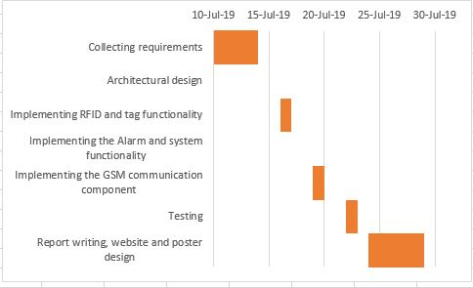
Figure 10: A Gantt chart showing the project work plan

Appendix B – Contribution by Team Members

No. | Team Member | Contribution
1. | Akol Sharon Norah | Identifying hardware components needed  Implementing the RFID reader and tag functionality  Designing the project website and uploading the project to the git repository  Designing the system Architecture
2. | Chekwech Emmanuel Isaiah | Identifying hardware components needed  Implementing the communication functionality of the system  Designing project poster
3 | Nalutaaya Viola | Implementing alarm system functionality  Identifying customer requirements

